***3) Enable VPC peering for cross account. (You can collaborate with your friend and do this task).***

🡪Go to, VPC console. Enter all setup for vpc and enable subnets, routing, and internet-gate way for public subnet.

🡪Go to, vpc peering... Create vpc peering 🡪 name vpc peering 🡪 select local vpc to peer with 🡪select your vpc id 🡪 selection based on your vpc to peer with 🡪 either you pair with your aws and also peer with another region in your aws. It has another option that we can peer with another aws account with same region (or) different region.

🡪We can add vpc id to connect different a/c with same region and also different region.

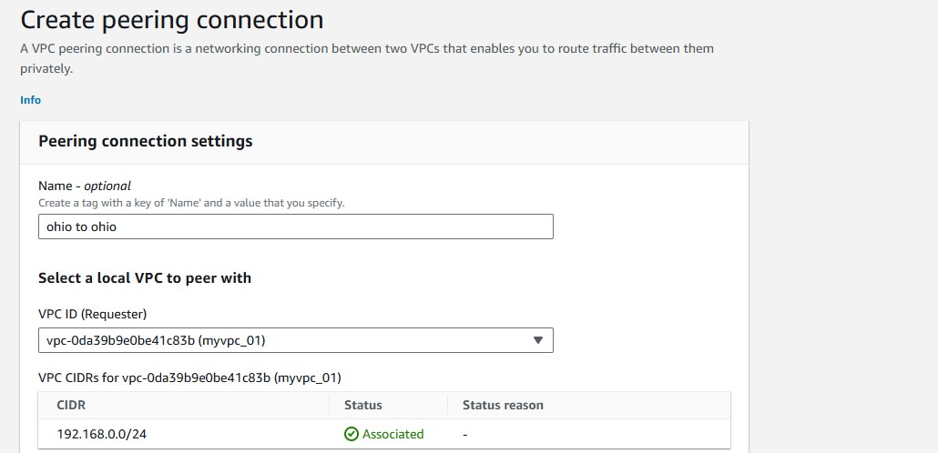

* Select Another account, add vpc id and also the aws account id

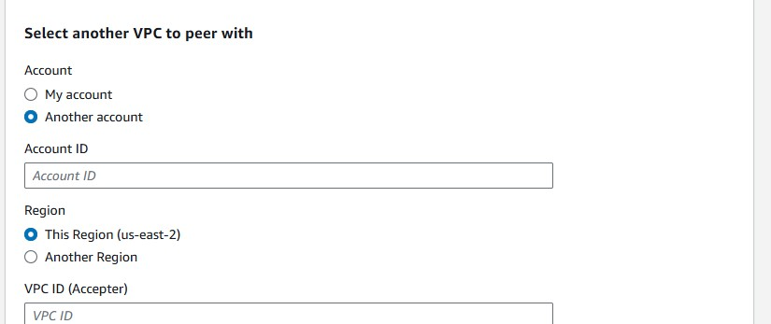

🡪Create vpc peering

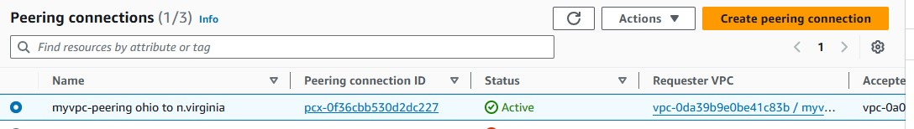

🡪 Accept the request that sent to the aws a/c that was peered.

* Take the ipv4 address form another aws a/c that was peered (another aws a/c vpc ipv4 address eg. 198.168.0.0/24).
* Copy that ipv4 address to your public subnet 🡪 in target add peering connection 🡪 save 